
Survey Site
Final Project
Version #5.0

All work Copyright © 2014 by Evan Pugh & Jordan Cooper.
All rights reserved.

Evan Pugh
Jordan Cooper

April-14-14

Table of Contents
Description Page 3.
Nav Bar section Page 3.
Color Selection Page 3.
Typography Page 4.
Wireframes Page 5.
Branding Selection Page 8.

Site Description

This site was created to allow users to develop their own surveys and post them to the general public. Anyone can become a user of the site by registering online, through the register page, where we will require their unique user name, password, and email address. Once the user is registered he or she can log in to the site and begin to access its survey development pages. This page offer the user the choice between a short-answer and agree/disagree and allows them to title their survey, and develop a five question survey and release it to the public for a pre-determined amount of time(determined by the owner of the survey). The site’s main page is open to the public, visitors are able to see a list of available surveys and by selecting one they are brought to the survey and prompted for answers. After the survey has been completed the user is thanked, and redirected to the home site. After a survey has been completed the owner of the survey can view statistics on his or her survey through our statistics page.

Navigation Bar

Desktop
Mobile

The navigation bar uses jquery mobile, when each page is selected through the navigation bar the selefcted page is highlighted in black. Each section of the navigation bar has its own unique icon that provides a visual indication about what each page will be about. The back button, part of the navigation bar, has been placed in the header(top left button) so the user may travel throughout the site and then go back to previous pages with ease.

Color Schemes

For this project I chose to keep my colors simple, using a light grey for the background (#cccccc) another grey, closer to white for the active link (#606060), the text is pure black on the page and in the nav bar it is white. The nav bar also has a light grey on the hover event. I kept the color scheme quite similar to the original web page to give the user a similar feeling when accessing the website from different platforms.

Background | #cccccc
Active link | 606060
Text | #000000
Nav bar text | #ffffff
Nav bar hover | #eeeeee
Button color | #808080
Button hover | #ffffff

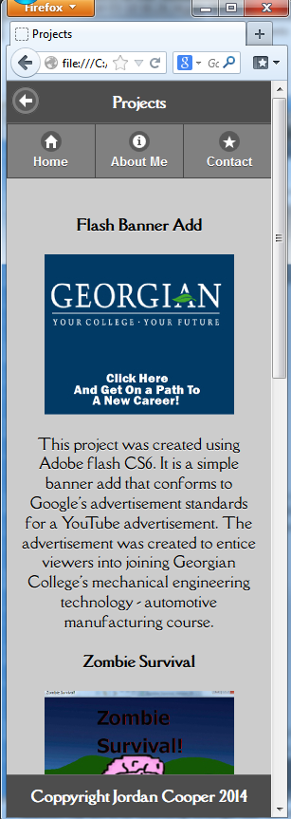
Typography Selections
Area | Font Size | Color | Font
Header  Represented by: “Projects” | 24pt  (H1 tag) | White | Della Respira  (Google Font)
Page Header  Represented by: “Zombie Survival” | 12pt  (H4 tag) | Black | Della Respira  (Google Font)
Page Text  Represented by:  “This project was created using Adobe flash CS6…” | 12pt  (P Tag) | Black | Della Respira  (Google Font)
Footer  Represented by: “Copyright Jordan Cooper 2014” | 12pt  (H4 tag) | White | Della Respira  (Google Font)

Wireframes

Home Page

Title text
logo

Navigation Bar

slider
Navigation For Slider

Tagline

Projects
Services

Desktop Mode

Footer

Back Button
About Me

Title text

Navigation Bar

Photo

Section Header

Section Text

Footer

Back Button
Contact Me

Title text

Navigation Bar

Contact Info
Buttons that auto dial/fill in email info

Email

Telephone

Linked In Image Button

IN

Footer

Back Button
Projects

Title text

Navigation Bar

Image Button of project

Image

Description

Footer

Back Button
Services

Title text

Navigation Bar

Service Title
Image

Description of Service offered

Footer

Back Button
Login

Title text

Navigation Bar

Log In
Username:
Password:

Footer

Back Button
My Contacts

Title text

Navigation Bar

Logout
Image

Contact’s Name

Footer

Branding Section

Logo
Colour: black

Screenshots
Home | About Me | Contact Me
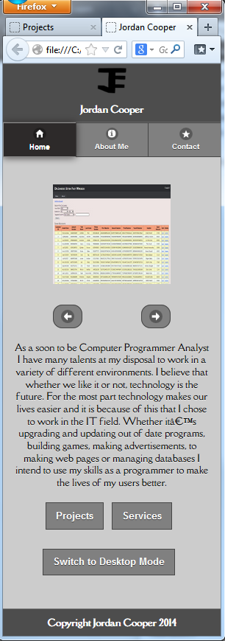 | 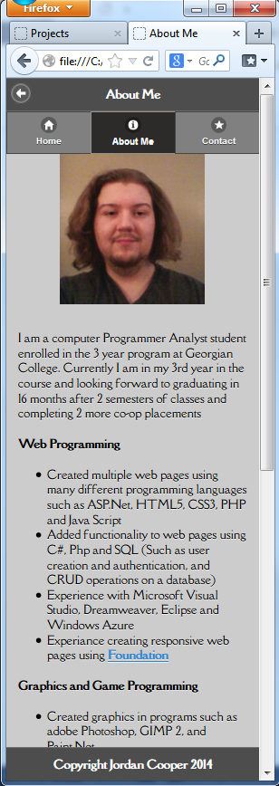 | 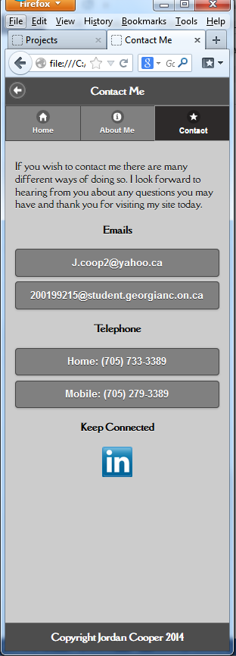
Projects | Services | Login
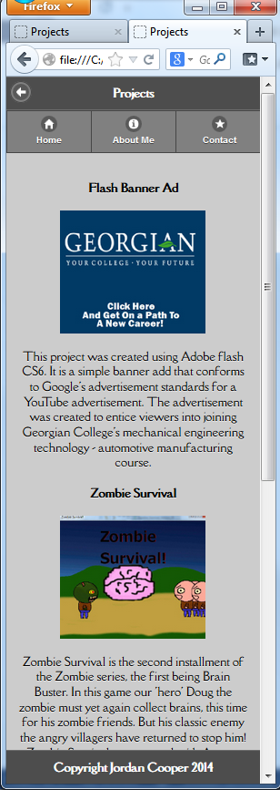 | 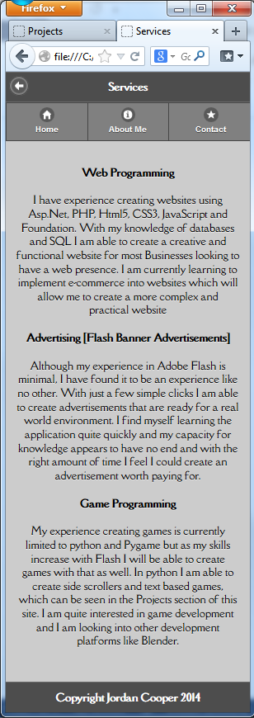 | 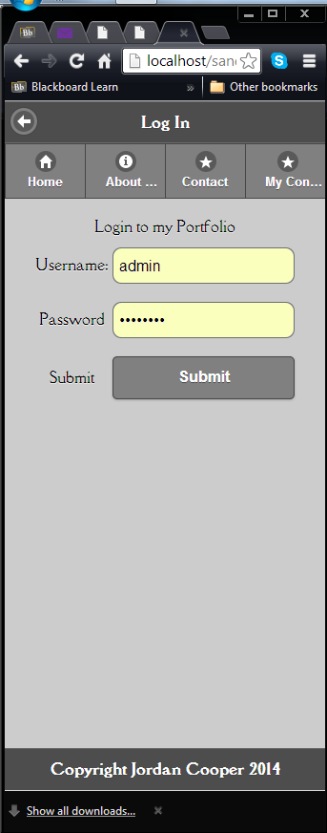
Contacts
